Project Module and API Design

**Feb 21, 2021**

**IST 412 Section 1, Professor Johnson Kinyua**

Aung Nay Htet Oo

Clarissa Pun

Sean Ristey

Jaden Roland

Kelvin Trang

# Class Cohesion

Each class/object holds its own purpose and interacts with each other at least once. The customer class represents a singular customer, holding data on the individual. The loan class identifies a loan and holds the functionality to edit the loan in any way, including calculating payoff and current loan balance. The UserData class is used to create and verify a customer. There also will be an account class (which has not been finished yet) that will connect the loans to a customer.

|  |  |  |
| --- | --- | --- |
| **Class** | **LCOM4** | **Comments** |
| Customer | 1 | Each attribute has its own getters and setters which are called by other methods. |
| Loan | 1 | Each attribute has its own getters and setters which are called by other methods |
| UserData | 1 | Rather than creating getters and setters for this class, it was more prominent we added functionality to create a secure login process for the customer. Each method accesses the variables directly to parse through and verify the user. |

# Diagrams

* Color is used to help clarify which relationships belong to which method

Customer Class:

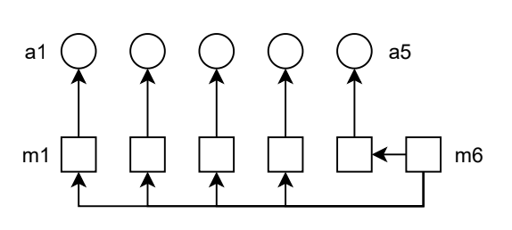

Loan Class:

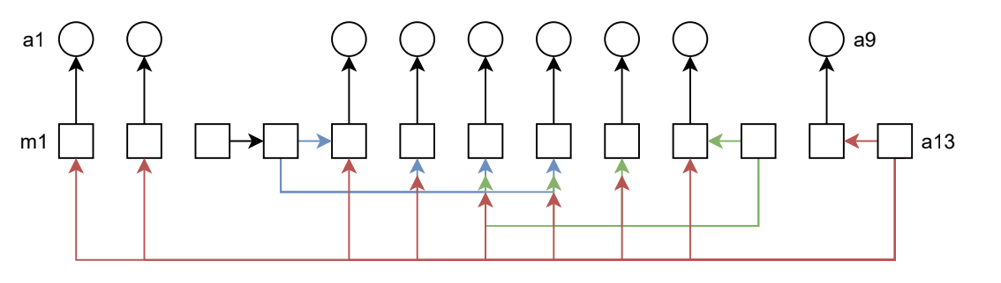

UserData Class:

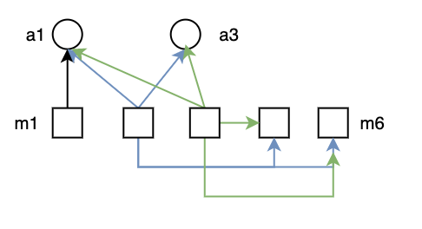

# Links

Github Link: <https://github.com/Ash195/IST412-Project>

Have branches with additional methods that have not been merged with the master.